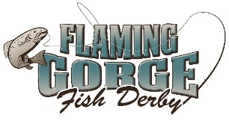
FLAMING GORGE FISHING DERBY
OFFICIAL RULES AND REGULATIONS
May 18-19, 2024
www.flaminggorgefishderby.com

- A team may consist of 2 to 3 members. All team members must fish together i.e., fish from same boat, shoreline, etc. Passengers are allowed in the boat, but cannot fish.
- Entry fee: $200.00 per team.
- Teams are required to register online at www.flaminggorgefishderby.com by May 10th or up to a maximum of 400 teams. Payment of registration will serve as a liability waiver for all team participants.
- All teams must check in for team registration at Lucerne Valley Marina on Friday May 17, 2024, no later than 8:00 pm. Registration opens at 11:00 am.
- Captains must be 18 years or older.
- Fishing times: Saturday – 5:30 am to 6:00 pm and Sunday – 5:30 am to 1:00 pm.
- Fish must be registered at Lucerne, Cedar Springs or Buckboard Marina weigh stations no later than one half (1/2) hour after the close of each tournament day. This means scales will be open from 6:00 am to 6:30 pm on Saturday and 6:00 am to 1:30 pm on Sunday. No exceptions.
- All entries except the Trophy Lake Trout will be based on weight, in case of a tie, length will be the determining factor.
- If the Trophy Lake Trout category is not filled, the prize money will be divided and paid into the other categories.
- The Derby is subject to cancellation due to weather conditions. The cancellation decision will be made by Derby officials, Lucerne Marina, the US Forest Service or Utah DWR. Anglers will be notified by Marine Band Radio, text or email.
- All contestants must observe all US Coast Guard, Wyoming Game & Fish, Utah DWR, Utah State Parks, US Forest Service, and Daggett/Sweetwater County rules and regulations concerning sport fishing and safe boating on Flaming Gorge Reservoir. This includes UT & WY AIS regulations.
- All of Lake Flaming Gorge is involved in the tournament. No boundaries, except for no fishing inside of the buoys of Buckboard, Lucerne & Cedar Springs Marinas.
- Closing ceremony will be at Lucerne Valley Marina where prizes will be awarded on Sunday, May 19, 2024 at approximately 3:00 pm. Cash prizes may increase or decrease depending upon the number of entries.
- There will be a heaviest, average team weight category for the Pup Lake Trout (see #5 of prize qualifications). All fish entered are subject to examination by fisheries biologists and derby officials.
- BASS MAY ONLY BE CAUGHT IN UTAH WATERS and weighed at either Lucerne Valley Marina or Cedar Springs Marina. Any contestant caught with bass in their possession in Wyoming will be immediately disqualified from the tournament.
- The Kokanee Category has been removed from the tournament until the kokanee population in the reservoir recovers. Prize money typically issued to this category will be spread across the remaining categories.
- Registration cancellations are non-refundable. Your registration will be forfeited or carried over to the following year.

Violation of regulations: All contestants must have a valid fishing license. Any participant who is cited for a violation of WGFD or UDWR Fishing, Watercraft or Aquatic Invasive Species Regulations while participating in the contest from 5:30 am on May 18th through 1:00 pm on May 19th, will be disqualified.
Culling is not permitted. The decision to release a fish or keep it for contest entry must be made immediately upon capture. Any fish caught that is not to be entered into the contest shall be immediately released to the water with as little injury to the fish as possible. Once a fish is put on a stringer, in a container or in a live well it cannot be released. Participants violating this rule will be disqualified.

AIS Inspection requirements: Any contest watercraft coming from out of the state of Wyoming by land from March 1 through November 30, is required to undergo a mandatory inspection by an authorized WY AIS inspector prior to launching. Participants violating that regulation will be disqualified. Derby Captains must provide their “Mussel Aware Certification” number from the Utah Division of Wildlife Resources and watercraft bow number in order to complete online registration. Please go to https://stdofthesea.utah.gov/ for more information and to complete the certification.

PRIZE QUALIFICATION IS BASED ON THE FOLLOWING:

- Trophy Lake Trout: Fish must be a minimum length of 40-inches for entry eligibility. Fish must be caught during derby hours on Lake Flaming Gorge. Lake Trout will be based on total length not weight. Ties will be determined by which fish was caught and submitted first. During online registration you will be required to declare if your team will be targeting trophy Lake Trout.
- Length qualification for Rainbow/Cutthroat and Brown Trout must be 18-inches or longer. Bass and Catfish have no size limit. Only one fish per category per angler may be entered throughout the tournament. Fish must be caught during derby hours on Lake Flaming Gorge. In case of a tie, length will prevail.
- Largest fish will be the heaviest fish from the individual species of Bass, Rainbow/Cutthroat or Brown Trout category. The largest fish by weight from one of these categories will get $2000.00. That fish will not be eligible for 1st place in its category but the larger amount. The next fish in line in that category will then move into the 1st place species and all other fish will move up one notch. This will spread the prize money out to more contestants.
- Anglers must be 13 or younger to enter a fish in the Youth Angler Category.
- Pup Lake Trout Category
  - Heaviest Average Team Weight of Lake Trout less than 25 inches wins.
  - Average team weight equals the total weight of Lake Trout entered during the contest divided by the number of members on that team. For example, a three-person team enters 108 pounds on Saturday and 116 pounds on Sunday equaling a total weight of 224 pounds. Their average team weight would be 74.7pounds (108 + 116 = 224; 224 / 3 = 74.7).
  - Per WGFD and UDWR fishing regulation, each team member may contribute up to one creel limit of lake trout per day (12 lake trout), not to exceed 24 lake trout (possession limit) after the first day.
  - Fish must be checked in each tournament day, no exceptions. Fish caught on Saturday cannot be entered on Sunday. To ensure fish are not entered both days, participants will be required to remove one lobe off each tail after checking in their fish and prior to leaving the weigh-in location.
  - The tie breaker will be the first team to enter Lake Trout less than 25-inches for their completed heaviest weight on Sunday. Fish greater than 25-inches will be disqualified and not count towards the heaviest weight. Derby officials make the final determination.

IMPORTANT - TROPHY LAKE TROUT CATEGORY DETAILS:
Trophy Lake Trout only: The large Lake Trout in Flaming Gorge are a resource that the Flaming Gorge Fish Derby, Utah Division of Wildlife Resources and Wyoming Game & Fish want to protect. We are providing a catch and release option for entering trophy Lake Trout into the derby. Lake Trout will not be weighed but will be measured for overall length. Fish must be freshly caught and be a minimum length of 40-inches for entry eligibility.
- Only one (1) Lake Trout per angler may be entered or in possession through the tournament.
- Lake Trout will be based on total length not weight. Ties will be determined by which fish was entered first.
- Anglers fishing for trophy Lake Trout are restricted to using flies and lures only, and may not use bait. Participants violating this rule will be disqualified.
- There are two options to enter the Lake Trout into the Derby: Digitally and Harvested. We encourage anglers to use the Digital Option. The FG Fish Derby will provide a measuring ruler, a special token and instructions for measuring Lake Trout at registration.

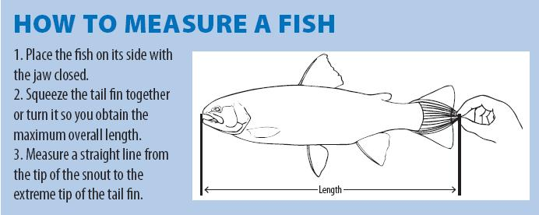

Note: In order for the fish to qualify, the picture must be taken from directly above the fish, not at an angle. The entire front of the ruler and line of the ruler must be clearly visible. The snout must be clearly visible at the beginning line of the ruler and the tail clearly visible in relationship to the ruler.

Digital Option – Via MyCatch App:
- Each Team will select one team member that will use their smart phone to complete Trophy Lake Trout entries (photos) for themselves and on behalf of the other team members. The designated team member will submit the Trophy Lake Trout entries to the Angler’s Atlas website via the MyCatch app. This is the only way to digitally enter Trophy Lake Trout into this contest. Only one team member should enter all Trophy Lake Trout for the team.
- Several days prior to the Flaming Gorge Derby the designated team member will need to create a free account at Angler’s Atlas: https://www.anglersatlas.com/. Once their account is active they will register for the Trophy Lake Trout category on the website by going to the Tournaments tab and looking for the category in the Active Tournaments tab or they can go to the following URL:https://www.anglersatlas.com/event/783/2024-flaming-gorge-fish-derby-2024
- All contestants entering in the Trophy Lake Trout category must read and acknowledge the detailed rules provided when registering for the tournament at Angler Atlas.
- Once accepted into the tournament, download the free MyCatch mobile app which is available for both iOS (Apple App Store) and Android (Google Play Store) and login to activate the tournament on the app using the same login email and password that you used to login to the Angler’s Atlas website.
- Anglers will measure the fish immediately upon capture with the provided measuring stick and the special token included in the registration packet.
- In order for each catch to qualify, a photograph of the fish on a measuring device must be taken using the MyCatch app (ie. photos cannot be uploaded from a photo gallery or other source). A great resource is the MyCatch video that shows how to log a tournament catch and can be viewed here: https://www.youtube.com/watch?v=OqwbAFFQE-w
- All contestants must have GPS/location services enabled on your cell phone for their catches to qualify. Angler’s Atlas does not release MyCatch GPS data to the public. It is treated as confidential and is provided to fisheries researchers under strict conditions.
- Catches that are submitted will be reviewed for approval frequently. The Catch Approval Team, made up of trained biology students, will be reviewing and approving all fish. Once the submissions are reviewed and approved, they appear immediately on the appropriate leaderboard(s). DO NOT EXPECT to see entries show up immediately after you log them.
- A photo that does not clearly show the overall length of the fish, including head and tail, and the token on the ruler WILL NOT BE SCORED. More than one attempt to get a valid scoring photo is allowed. The app will prompt you to either accept the photo or retake a photo.
- The app works out of cell range, and catches will synchronize with the server once the user opens the app when back in cell range, or via a Wi-Fi signal. Photos are date, time, and location stamped to the moment that they are taken. If the catches are not synced by the prizing deadline, they will not qualify for prizes.
- Any ties will be resolved by which fish is caught first.
- IMPORTANT: Arguing against or trying to attribute reason as to why any of the above rules could not be followed will have ZERO bearing on the ruling of a rejected fish. “It was cold/windy” or “My partner can verify...” will not be considered, and NO exceptions will be made. It is the angler’s responsibility to review their photo thoroughly and submit an acceptable photo based on the above rules.

Harvest Option:
- If a participant does not register the fish using MyCatch, then the actual fish will need to be entered at one of the weigh stations. Per Wyoming Game & Fish and Utah Division of Wildlife Resources regulations, fish entered at a weigh station must be dead prior to leaving the lake.

INCORRECT PICTURE

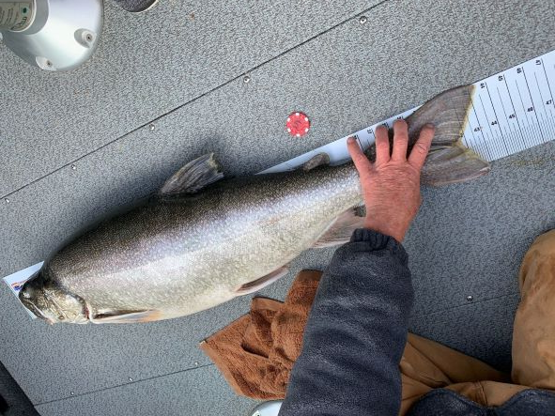

CORRECT PICTURE

